DRAFT Honours Project Proposal:
Capacity Control in Boosting via an Adjustable b Function
Jeremy Barnes
Supervisor: Dr Bob Williamson

Introduction
The aim of this document is to provide some detail on the scope and implementation of this honours project. A brief background on the project is given; followed by an explicit statement of the expected outcomes; and a timeline.

Background
Boosting is a method used to improve the generalisation ability of a “weak” learning algorithm. It is implemented by generating many instances of the algorithm, each trained on different data. This data is chosen such that examples which are commonly misclassified are emphasised. This forces the learning algorithm to work well with the difficult data, and have better overall performance. The output of the boosting algorithm is a weighted combination of the outputs of the weak learning algorithms (weighted by their performance).
Adjusting the capacity of a learning algorithm controls the size of the set of possible generalisations. It is important to control capacity to avoid overfitting (fitting the noise rather than the underlying function). Although boosting is particularly good at avoiding overfitting, implementing capacity control can improve the performance of the boosted algorithm [ref] and avoid eventual overfitting.
The b function is used within the boosting algorithm. It is calculated for each instance of the weak learning algorithm, from the learning error of the weak learning algorithm (the learning error is the proportion of samples which are misclassified). In the case of a binary classification problem, it has the form

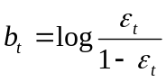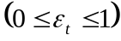

where 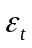 is the learning error of weak learning algorithm .
This function describes the worth of this instance of the weak learning algorithm. A plot is shown in figure 1.

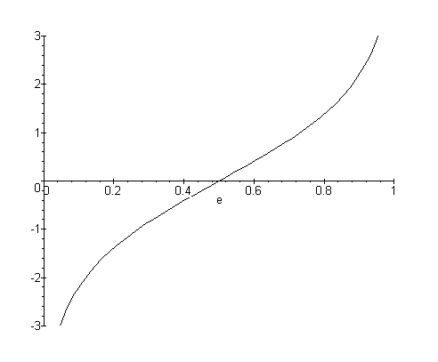
Figure 1: The b function versus error

Weak learners with a value of around are worthless, as random guessing performs just as well. As moves away from , the algorithms become more useful (and show an increase in 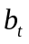). Algorithms that approach 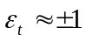 are given a that approaches 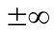.
This project will investigate modifying the b function to become

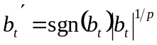

The new parameter p allows control over how aggressively weak learners are penalised. This should allow capacity control via adjustment of this parameter.

Outcomes
The project will be successful if the following outcomes are attained:

- Enough experimental evidence is gathered to gain an appreciation of the effect of the  parameter on the boosting algorithm.
- From this evidence, some guiding principles for improving the performance of the boosting algorithm using the parameter are developed.
- Theoretical justification of these results is obtained.

In addition to these goals, it is hoped that progress in one or more of the following areas will be made:

- Performance of the algorithm in problems with varying amounts of noise;
- Improved versions on the p-boosting algorithm using knowledge gained from the theory;
- Improving the computational efficiency of boosting using the p-boosting algorithm;
- Comparisons between p-boosting and other methods of capacity control in boosting;
- Extension of the results to include arbitrary classification problems;
- Extension of the results to include regression problems;
- Extension of the results to include other enhancements to the boosting algorithm, such as “soft margins” [2]

In order to limit the project to a reasonable scope, initially the following constraints will be placed:

- Only binary classification problems will be considered.
- Small datasets will be used.
- Simple weak learning algorithms will be used.

Timeline
This section includes a month-by-month description of what I intend to complete on the project.

Month | Tasks
December 1998 | Reading
January 1999 | Reading
February | Reading
March | Writing project proposal  19th Project proposal due  Obtaining or writing code for experiments
April | Writing, debugging code  12th Code running, first test results  Obtaining datasets, running tests, refining code
May | Running tests  Developing and testing hypotheses  Reading on theory  31st First draft of “background” section of thesis
June | Initial attempts at theoretical analysis  Running tests required for theoretical verification  Attempting to reach closure on some aspects  Exam period
July | Attempting to reach closure on some aspects  Writing progress report  19th Progress report due  Preparing for seminar  26th Seminar
August | Final work on theory  Final experimental results to assist theory  30th Sufficient work done to complete thesis
September | Work on spin-off or extension aspects  Preparing for demonstration  27th All experimental and theoretical results obtained  Writing thesis
October | Writing thesis  7th Draft thesis due  Revising thesis  27th Thesis due  28th Demonstration

Notes
- I intend to work on the thesis gradually throughout the year, so that I do not need to write it all at the end.
- I have allowed 2-3 weeks to work on “extension” aspects of the problem that are interesting but not vital to a strong thesis. It would not be a serious problem if none of this work can be included in the thesis. These 2-3 weeks also give me some slack if things are not going as planned or if I become burnt out and need a break.

References
- Yoav Freund and Robert E. Schapire. Experiments with a New Boosting Algorithm. Machine Learning: Proceedings of the Thirteenth International Conference, 1996.
- G. Rätsch, T. Onoda, K.-R. Müller. Soft Margins for AdaBoost. August 31, 1998.

This project was originally called “Aspects of Statistical Learning Theory and Support Vector Machines”.

